**Machine Learning Project Idea document**

**SUBMITTED TO: DR SHER MUHAMMAD DOUDPOTA**

DECmber 8, 2022

Sukkur IBA University

**Semester PROJECT PROPOSAL BY:**

**RANJEETA (023-19-0104)**

**isha MUGHAL (143-19-0007)**

**jahanzaib (143-19-0030)**

Music RecoMmendation System

**Table of Contents**

**Introduction 3**

**Problem Statement: 3**

**Aims and Objectives: 3**

**Proposed Methodology: 4**

**Dataset Discussion: 4**

**Major Outcomes: 4**

**Conclusion 4**

**References 5**

# Introduction

A recommendation system is a type of information filtering system that tries to predict user preferences and make recommendations based on those preferences. There are many applications for recommender systems. These have become increasingly popular over the past few years and are now used on most of the online platforms that we use in our daily lives. Such as YouTube, Facebook, Netflix, Spotify, etc. Such platforms' content varies from movies, music, literature, and video to friends and stories on social media platforms. In many cases, these systems can collect information about your choices and use that information to improve future suggestions. For example, have you ever wondered that how spotify predicts a new playlist to user? Spotify can monitor your interactions with different songs in your history. In some cases, recommender systems can make improvements based on the activities of a large number of people. For example, if a song is not played to your choice or your preference, then you might stop listening songs from that site. This has given tech companies a lot of focus on improving recommender systems. However, the problem is more complicated than imagined. Each user has different tastes and preferences. Moreover, even a single user's preferences can vary depending on various factors, such as the user’s mood or the type of activity the user is doing. For example, the type of song you want to listen when you are happy is very different from the type of song you want to listen when you are sad. To get around this, we'll create a machine learning algorithm that will be used to find the songs that users are most likely to listen.

Basically, there are two major approaches that are widely used to create recommender systems. Of these, the first is “content-based filtering”, which profiles user interests based on the information gathered and recommends articles based on that profile. The other is “collaborative filtering”, which aims to group like users together, and uses group information to provide suggestions to the individual.

Many factors can be taken into account when designing a song recommendation system, including the genre of the song, the voice of that song, even the artist as well. The systems can make recommendations based on one, two, or more attributes. The approach that we are going to use is content-based approach.

# Problem Statement:

Sorting out all the digital music is very time consuming and cause information drowsiness. Therefore it is necessary to build up a recommendation system. That can search in the music libraries automatically and suggest suitable songs to users. Our recommendation system recommends different songs based on content-based filtering. Before recommendation we will face difficulty in our system. That is Suppose that, if a person likes a song, then how we can make prediction that user might like song features such as audio, genres, artists and few more.

# Proposed Methodology:

In this section we will perform first data exploration and then preprocessing on dataset after that we perform k means clustering and then we will build a class of recommendation system that recommend a song to the user. In preprocessing techniques such as to remove duplicate values and remove null values. In general, we select some of the features that play role in recommendations and remove all others features that doesn’t impact on our results. Recommendation is based on audio features of the data set.

# Aims and Objectives:

Following were the objectives of the proposed project:

1. To develop a music recommendation system which will recommend song on basis of current music
2. To reduce the time and efforts needed for sorting of songs of our choice.
3. To eliminate the need searching for a song manually.

# Dataset Discussion:

To create music recommendation system we will use a dataset that is collected from spotify. This dataset contains over 175,000 songs with 19 features. The dataset contains many different measures on songs. Some of the names give the idea what they mean like tempo, dance ability, liveliness, speechiness and many more. Some of them are correlated. These features are audio features, which perform major role in our recommendation system. This dataset contains a lot of content, that’s why we are taking this for our project.

# Major Outcomes:

After the completion of project we will develop a web application with a trained model to recommend songs to the user as many as user wants. We will ask user to enter the song name and the number of songs he/she wants like that song. The expected outcome is that our algorithm will recommended songs.

# Implementation of project:

We implement our project using Google collab in which we started with data exploration and then transformation we implement k means and Kmean++, we made a manual class Spotify_Recommendation in which we are recommending songs to user on basis of least distance ,songs are being recommended. We deploy the project with web application using Flask we have created 1 page of html index.html, we created a main.py to deploy the project using a web application developed in flask.

1. This is the initial page of our app in which we ask a user for enter song and the number of song.

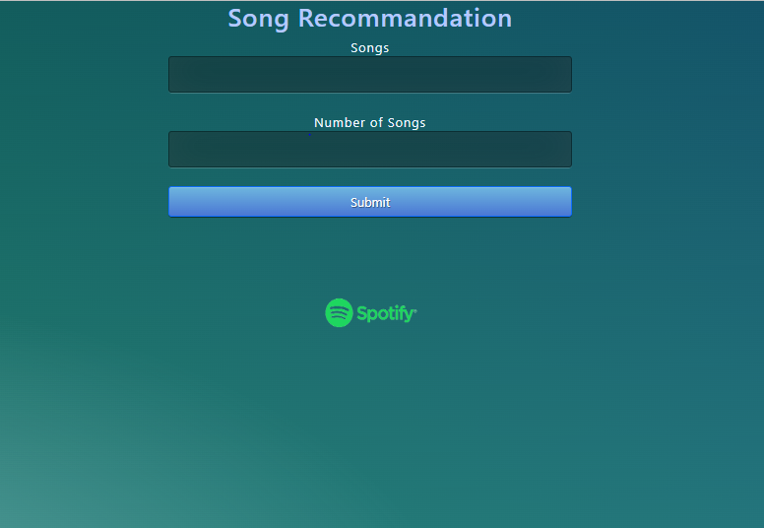

1. Where you type the current song.

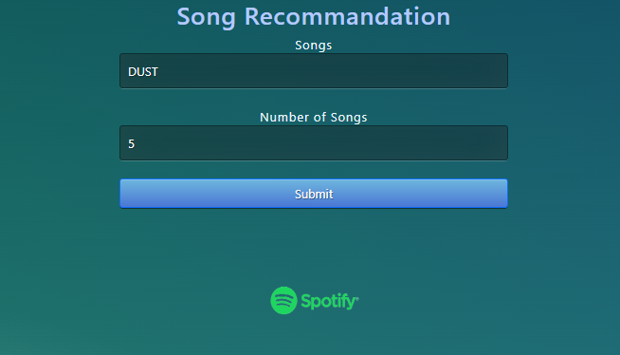

1. This is the 3rd screen where the output is printed using flask table.

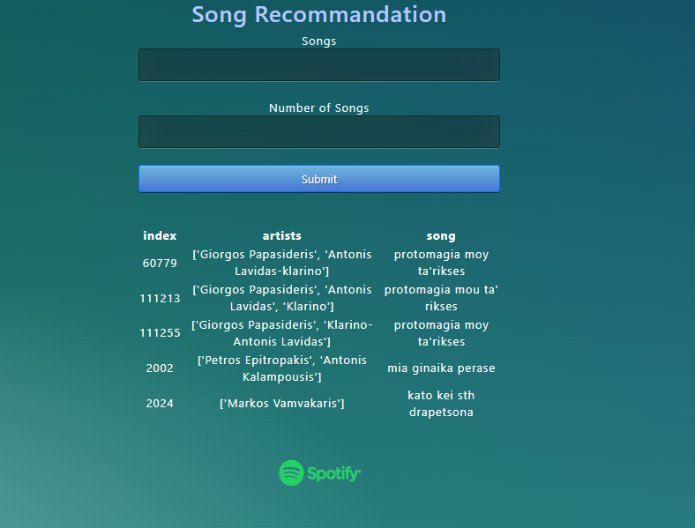

1. When you search for the song which is not available in dataset it will show song is not available.

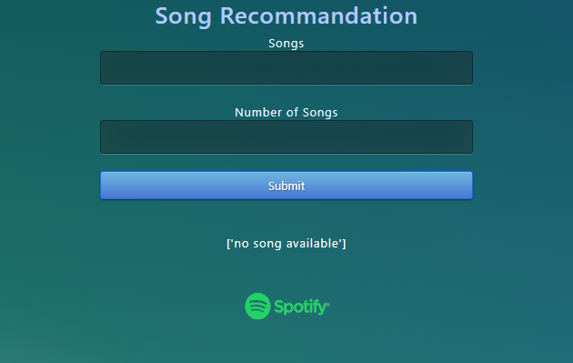

# Conclusion

We introduce a content-based recommended system it reduces the time for searching the song. By using music recommender system our algorithm can predict and then offer appropriate number of songs to the user based on the quality that has been heard previously. We use metric to measure distance between weighted features of different songs. After computing similarities, we recommend user similar songs.

# References

1. <https://www.sciencedirect.com/science/article/pii/S1877050919310646#:~:text=By%20using%20music%20recommender%20system,that%20has%20been%20heard%20previously>
2. <https://towardsdatascience.com/a-practical-guide-to-exploratory-data-analysis-spotify-dataset-d8f703da663e#:~:text=Dataset%20contains%20more%20than%20160.000,is%20from%201921%20to%202020.&text=There%20is%20no%20missing%20value>